**SPRINT 4**

|  |  |
| --- | --- |
| Team ID | PNT2022TMID50177 |
| Project Name | Smart Waste Management System for Metropolitan Cities |

**NODE RED UI:**

**Node-red-dashboard**

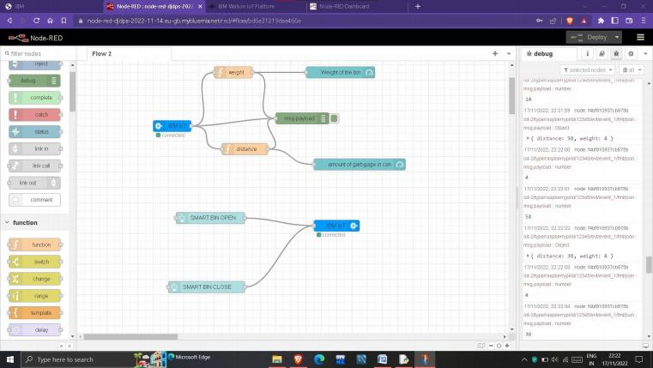

**The data to nodes in the node-red are provided with the help of the python script via the ibm cloud which is considered to be the data from the data**  
**values from the sensor.**

**To calculate the distance ultrasonic sensor is used, and as well as to calculate the weight weight sensor is used.**

**There are certain assumption sassumed by us, They are**

•**The length of the trashcan is assumed to be 200cm.**

•**The maximum weight of the can is assumed to be 2Kg.**

•**If the garbage distance goes more than 180cm i.e more than 90% of**

**the trashcan, the sensor is has to send to send an alert to the garbage** **collector.**

•**If the alert is received, then the garbage collector has to come and collect the garbage.**

•**The current weight and the garbage distance is to be updated periodically, i.e for 5minutes**

**FUNCTION CONFIGURATION FOR WEIGHT:**

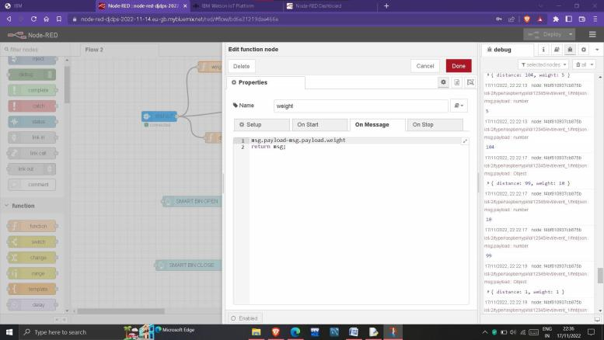

**FUNCTION CONFIGURATION FOR AMOUNT OF GRABGE IN CAN:**

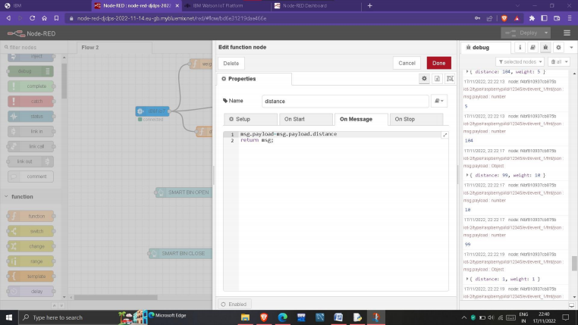

**UI:**

**A simple webpage which shows the amount of garbage in the smartbin and indicates free space in the trashbin. Then the webpage also displays the weight of garbage present in the smartbin.It can hold a maximum of 10kg**

**and at the same time the length of the smartbin is 200cm. Aalert message is sent if the requirements are passed, and then the current coordinates of the smartbin is being sent to the garbage collector.**

**The webpage also composed of two buttons, with the help of the buttons we can open the smartbin and as well as close the smartbin. The command from the user is sent to the sensor and the dustbin is closed and as well as**

**STORING THE DATA IN IBM CLOUDANT DB:**

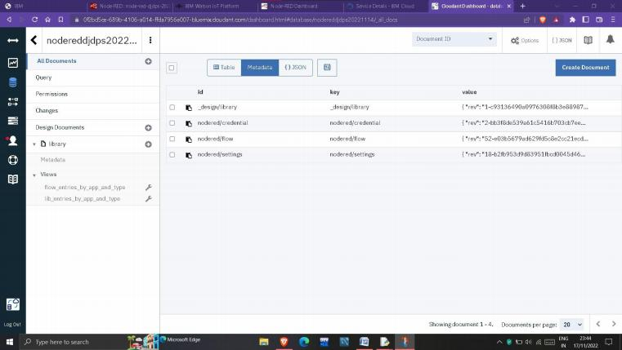

**DASHBOARD:**

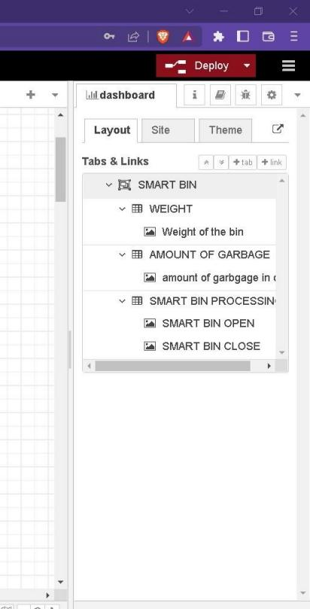

**WEB UI:**

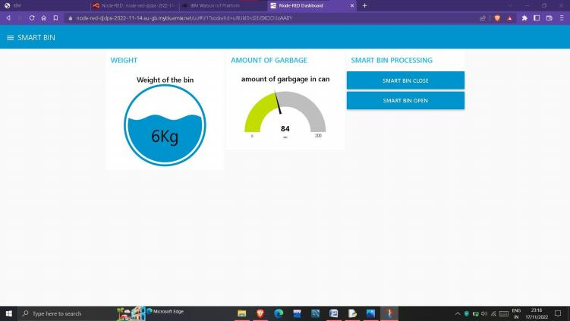

**Here the web page denotes the weight of garbage present in the** **smartbin and as well as the, length of the smartbin filled with garbage in the above the current garbage weight is 6kg and as well as the length of smartbin filled with garbage is 200cm.**

**There is button for smartbin processing, if we want to open and** **close the smartbin, we can perfom this with the help of the buttons. The data will be sent from the user interface to the sensors and the required** **operation is performed.**

**The command from the web user is sent to the sensors successfully.**

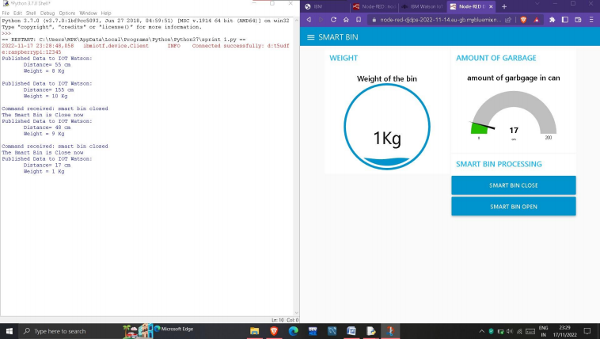

**The command for closing the smartbin is received and it also has been executed successfully.**